**Green Society Public School**

**D-10**

**Ratnanagar-7, Sauraha, Chitwan**

**Second Terminal Examination-2082**

**Class: Two Time: - 1 hr. F.M.: 25**

**Sub: English II**

|  |
| --- |
| **Name: Roll No.: Sec.:** |
| **­­­­­­­­­­­­ ________________ ______________ OBT.MARKS:**  **INVIGILATOR EXAMINER** |

**1. Read the passage and do the activities given below. (4)**

Caterpillars eat leaves. They have a soft body. They have pine on their body. They breathe through the little holes on the side of their body. They gave many friends and they love to play with them.

a) What do caterpillars eat?

i) Chocolates ii) Leaves iii) Fruits

b) Who has a soft body?

i) deer ii) cat iii) caterpillars

c) Caterpillars have ________on their body.

i) spike ii) pine iii) horn

d) Caterpillars breath through_______.

i) holes ii) heart iii) lungs

**2. Choose the correct antonyms (opposite) for each word from the box. (4×0.5=2)**

Eg. hot – **cold**

a) Fast _________ b) Right___________

c) Rich_________ d) Happy__________

|  |
| --- |
| Wrong , Slow, Sad , Poor , Cold |

**3. Write the vowel letters in the box. (4×0.5=2)**

|  |  |
| --- | --- |
| **o** | **e** |

Eg. **Monkey**

|  |  |
| --- | --- |
|  |  |

a) dinner

|  |  |  |
| --- | --- | --- |
|  |  |  |

b) animal

|  |
| --- |
|  |

c) horn

|  |  |  |
| --- | --- | --- |
|  |  |  |

d) orange

**4. Change into plural by adding – ‘s’ (4×0.5=2)**

eg :- egg – **eggs**

a) crow - _______ b) dog- _________

c) book - _______ d) farmer- ________

**5. Fill with ‘a’ or ‘an’ in the blanks space. (4×0.5= 2)**

eg **An** apple.

a) ______onion b) ____gun c)_____parrot d) ______ mango

**6. Match the picture with the correct sentences (4×1=4)**

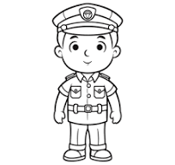

a) policeman * teaches in a school



b) A nurse * catch thieves or robbers

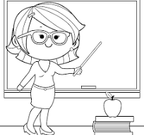

c) A Teacher * help sick people



d) Fisherman * catch fish

**7. Write ‘M’ for Masculine and ‘F’ for Feminine gender. (6×0.5 =3)**

eg :- king –

**M**

a) father - b) brother- c) wife-

d) cow- e) daughter- f) dog -

**8. Underline the verbs and write them in the blanks. (4×1 = 4)**

eg : - She **cooks** well.  **Cooks**

a) They play the guitar. ________________

b) I read my book. ________________

c) We write ourselves. ________________

d) She eats an egg. ________________

**9. Fill in the blanks with correct preposition. (4×0.5 = 2)**

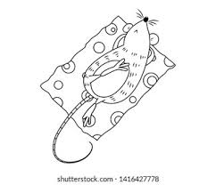

Eg. The mouse is **on** the mat. (In, on, at)

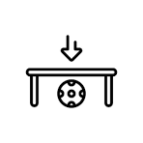

a) The ball is _______the table. (under, above)

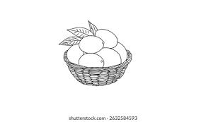

b) The mango is _____the basket. (on, in, at)

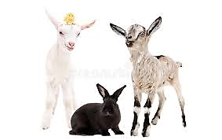

c) The rabbit is _____________two goats. (between, above, under)

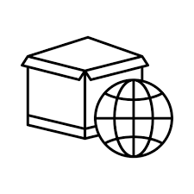

d) The ball is _______the box. (Inside, outside, )

**The End**